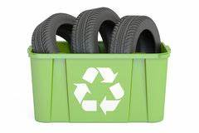
FREE TIRE RECYCLING EVENT
Thurs., Jan. 20 - Sat., Jan. 22, 2022
Freestone County residents are encouraged to bring disposable tires to this event:
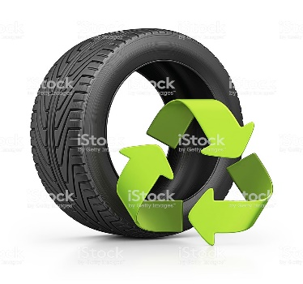
Event Location: Dew Dump
137 FM 489
Fairfield, TX 75840
Event Times: Thur. – Fri.: 10am - 5:00pm (or trailers are full)
Sat.: 8am - 2:00pm (or trailers are full)
**Tire Amnesty Event provided by grant funding from Texas Commission on Environmental Quality (TCEQ), Heart of Texas Council of Governments (HOTCOG) in conjunction with Freestone County.

Important Information:
- No Cost……
- NO TRACTOR TIRES or HEAVY EQUIPMENT TIRES
- All Tires must be off the rims
- Residential Tires ONLY, NO Businesses…
- Be prepared to unload your own tires.
- Tires will be accepted during event times, please do not drop off tires before or after event
For more information please call 903-389-8226 or 903-389-2180

